Date | 25-06-2025
Team ID | LTVIP2025TMID47835
Project Name | Resolver
Maximum Marks
User Acceptance Testing (UAT) Template
Project Overview:
Project Name: Resolver
Description: An online complaint registration an management system is a software application or platform allows individuals or organizations to submit and track complaints or issues the have encountered.
Project Version:v1.0.0
Testing Period: 2025-05-26 to 2025-06-02
Testing Scope:
● User registration and login
● Complaint Submission
● Status Tracking
● Agent Communication
Requirements to be Tested:
● As a Client of Resolver, I want to Post the complaints easily.
● As a user, I want secure login and Post complaints.
● As an admin, I want to manage reported users and disputes.
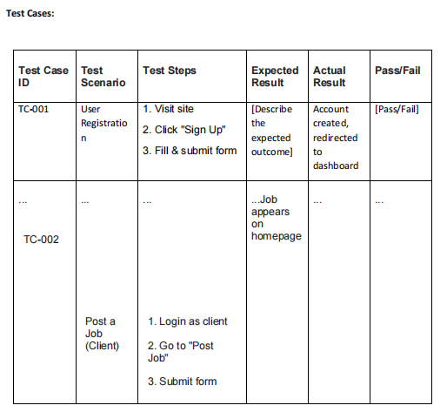
Notes:
● Ensure that all test cases cover both positive and negative scenarios.
● Encourage testers to provide detailed feedback, including any suggestions for improvement.
● Bug tracking should include details such as severity, status, and steps to reproduce.
● Obtain sign-off from both the project manager and product owner before proceeding with
deployment.

